Assignment 3 (100 points, Chapter 5)
Submission: Please type your answers in this WORD file and submit to Tracs. Please also zip all the created *.jff files into a single file and submit to Tracs.
Note: You do not need to answer questions labeled with “self-study”, but you’re required to study them.

1. (10) Consider the following DFSM M:

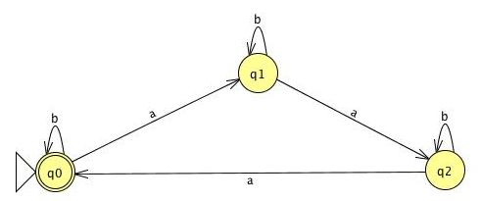
List the first ten elements of L(M) in lexicographic order (shortest first, then alphabetically if same length).

2. (30) Build a deterministic FSM for each given language. You should use JFLAP to create a *.jff file. Cut and paste the figure from JFLAP. For each question, a list of testing strings are also given. In JFLAP, run your created FSM on the testing strings (Click Input then Multiple Run. Input all the testing strings and click Run inputs). Indicate which of the testing strings are accepted. Your answer MUST be based on the actual running results from JFLAP.

(1) {w ∈ {a, b}* : every a in w is immediately preceded and followed by b}
Testing strings: ,a,b,aa,ab,ba,bb,bab,aba,bbb,abab,baab,baba,babab

(2) {w ∈ {0, 1}* : w corresponds to the binary encoding, without leading 0’s, of natural numbers that are powers of 4}
Testing strings: ,0,1,01,10,11,100,101,1000,1010,10000

(3) {w ∈ {0, 1}* : w has 001 as a substring}
Testing strings: ,0,1,01,000,001,0001,0010,0101,11000,110010

(4) {w ∈ {0, 1}* : w does not have 001 as a substring}
Testing strings: ,0,1,01,000,001,0001,0010,0101,11000,110010

(5) {w ∈ {0, 1}* : none of the prefixes of w ends in 0}
Testing strings: ,0,1,00,01,10,11,110,101,111

(6) (self-study) {w ∈ {a, b}* : every b in w has one a immediately to its left and two a’s immediately to its right}.
Testing strings: ,a,b,bb,aaa,abaa,aabaa,ababab,abaabaa

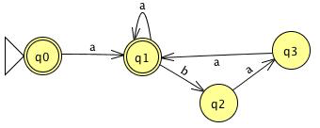
Accepted strings: ,a,aaa,abaa,aabaa,abaabaa

3. (10) Consider the following NDFSM M:

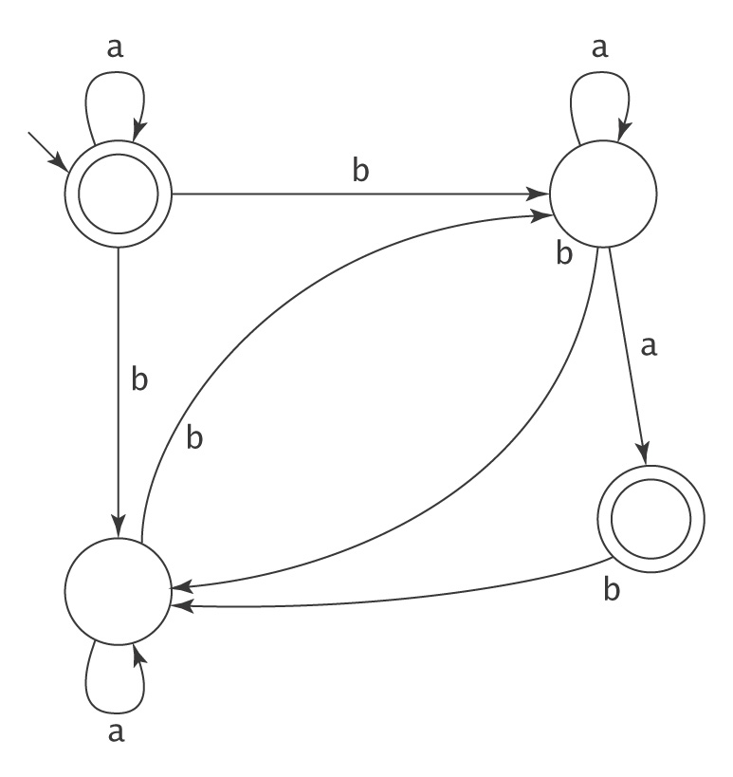
List the first ten elements of L(M) in lexicographic order (shortest first, then alphabetically if same length).

4. (20) Build a possibly nondeterministic FSM for each given language. You should use JFLAP to create a *.jff file. Cut and paste the figure from JFLAP. For each question, a list of testing strings are also given. In JFLAP, run your created FSM on the testing strings (Click Input then Multiple Run. Input all the testing strings and click Run inputs). Indicate which of the testing strings are accepted. Your answer MUST be based on the actual running results from JFLAP.
(1) {w ∈ {a, b}* : w contains at least one instance of aaba, bbb or ababa}
Testing strings: ,a,b,bbb,aaaa,aaba,aabb,abba,abbb,bbab,bbba,ababa,aabaa, baaba,ababab,ababbabba

(2) {w ∈ {0, 1}* : w corresponds to the binary encoding of a positive integer that is divisible by 16 or is odd}
Testing strings: ,0,1,10,11,100,101,1000,10000,11000,100000,110000,1010000

5. (30) This question is about Markov chain and its applications. It involves self-learning. You’re required to study the problem description, and possibly other relevant online materials. The following description modifies and extends content from the following page: Examples of Markov chains (http://en.wikipedia.org/wiki/Examples_of_Markov_chains).

A very simple weather model
The probabilities of weather conditions (modeled as either rainy or sunny), given the weather on the preceding day, can be represented by a transition matrix:
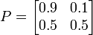
The matrix P represents the weather model in which a sunny day is 90% likely to be followed by another sunny day, and a rainy day is 50% likely to be followed by another rainy day. The columns can be labeled "sunny" and "rainy", and the rows can be labeled in the same order.
(P)_{i j} is the probability that, if a given day is of type i, it will be followed by a day of type j. Notice that the rows of P sum to 1: this is because P is a stochastic matrix.
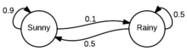
State diagram representing P

Predicting the weather
The weather on day 0 is known to be sunny. This is represented by a vector in which the "sunny" entry is 100%, and the "rainy" entry is 0%:
The weather on day 1 can be predicted by:
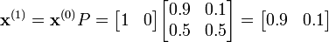
(Note: in the above calculation, 1 * 0.9 + 0 * 0.5 = 0.9 and 1 * 0.1 + 0 * 0.5 = 0.1)
Thus, there is a 90% chance that day 1 will also be sunny.
The weather on day 2 can be predicted in the same way:
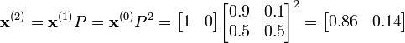
or
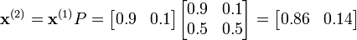
General rules for day n are:

Steady state of the weather
In this example, predictions for the weather on more distant days are increasingly inaccurate and tend towards a steady state vector. This vector represents the probabilities of sunny and rainy weather on all days, and is independent of the initial weather.
The steady state vector is defined as:
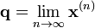
q converges to a strictly positive vector only if P is a regular transition matrix (that is, there is at least one P^{n} with all non-zero entries).
Since the q is independent from initial conditions, it must be unchanged when transformed by P. This makes it an eigenvector (with eigenvalue 1), and means it can be derived from P. For the weather example:
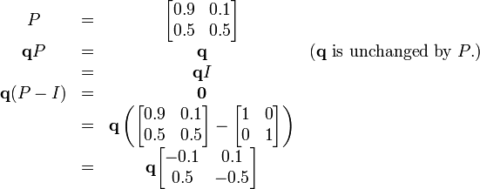

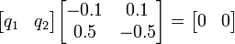
So and since they are a probability vector we know that
Solving this pair of simultaneous equations gives the steady state distribution:
In conclusion, in the long term, about 83.3% of days are sunny and 16.7% of days are rainy.

The power method
Instead of solving the equations, we can use the following power method to approximate the steady state vector q. As in the above example, suppose the initial vector for day 0 X⁽⁰⁾ = [1, 0], then:
X⁽¹⁾ = X⁽⁰⁾ P = [0.9, 0.1]
X⁽²⁾ = X⁽¹⁾ P = [0.86, 0.14]
X⁽³⁾ = X⁽²⁾ P = [0.844, 0.156]
X⁽⁴⁾ = X⁽³⁾ P = [0.8376, 0.1624]
X⁽⁵⁾ = X⁽⁴⁾ P = [0.83504, 0.16496]
X⁽⁶⁾ = X⁽⁵⁾ P = [0.834016, 0.165984]
X⁽⁷⁾ = X⁽⁶⁾ P = [0.8336064, 0.1663936]
X⁽⁸⁾ = X⁽⁷⁾ P = [0.83344256, 0.16655744]
…

Observe that the vector converges as the computation goes on. We can stop this process if the vector doesn’t change much in its values (within a threshold) comparing to the last iteration. For example, because X⁽⁸⁾ ≈ X⁽⁷⁾, we can stop at X⁽⁸⁾ and consider the steady vector q ≈ X⁽⁸⁾.

Question (1): The long term steady state vector q is independent of the initial vector. To verify this statement, let’s consider the same transition matrix P as in the weather example but use another initial vector of [0.5, 0.5] (the values must sum up to be 1). Follow the power method to approximate q. You may use 0.001 as the threshold or simply stop at X⁽⁷⁾.
Your answer to Question (1):

PageRank
Google’s PageRank algorithm is essentially a Markov chain over the graph of the Web, where each webpage is considered a state. The PageRank values of pages measure the popularity (a static quality) of pages and are used in Google’s search result ranking (along with other heuristics). In the weather model, the weather enters different states, and the steady state vector represents the probabilities of the weather entering the states on all days. Here, a web surfer enters/visits different states (pages), and the steady state vector represents the long term visit rates of the pages (i.e., probabilities of pages being visited within an indefinite time span) by the surfer. Long term visit rates = PageRank values. The larger the visit rate, the larger the popularity of the page.
Thus, PageRank values can be computed based on the method described for the weather model. Similarly, the choice of initial vector is unimportant. As long as we have the transition matrix P defined, we can apply exactly the same method. Since the number of pages on the Internet is huge, the power method is more practical and efficient in computing the steady state vector.
The transition matrix P is based on the random surfer’s surfing behavior. The surfer follows out-links, with equal probability, to visit the next page. Since there might be dead-end pages (where the pages don’t have any out-links to follow) or isolated subgraphs (where the surfer may get stuck in the subgraph), in order to have every page being visited, we must allow the surfer to restart by introducing a “teleporting operation” associated with a teleporting probability (or restart probability) α. At a dead-end page, the surfer will restart and enter any page with equal probability (in other words, the visiting probability of 1 will be shared among all pages equally). At a non-dead page, the surfer has α probability to restart and enter any page with equal probability (in other words, the visiting probability of α will be shared among all pages equally), and has (1 - α) to follow out-links with equal probability to visit the next page (in other words, the visiting probability of 1 - α will be shared among all the out-linked pages). This surfing behavior description should allow you to compute the transition matrix P for a given web graph and a given α. If you still have difficulties, there are tons of online materials that may help. You may also study the relevant chapters (e.g., chapter 21) in the following book: Introduction to Information Retrieval (free at http://nlp.stanford.edu/IR-book/information-retrieval-book.html).

Question (2): Given the following web graph, given restart probability α = 0.12, compute the transition matrix P and draw the state diagram representing P.
C
B
A
Your answer to Question (2):

Question (3): Use the power method to approximate the PageRank values for the pages (i.e., the steady state vector q) in Question (2). Again the choice of initial vector is unimportant. Let’s just use [0.5, 0.5, 0]. Note that the values in a vector must sum up to be 1 because the surfer must be in one of the states (visiting one of the pages) at a time. You may use 0.001 as the threshold or simply stop at X⁽⁶⁾.
Your answer to Question (3):

